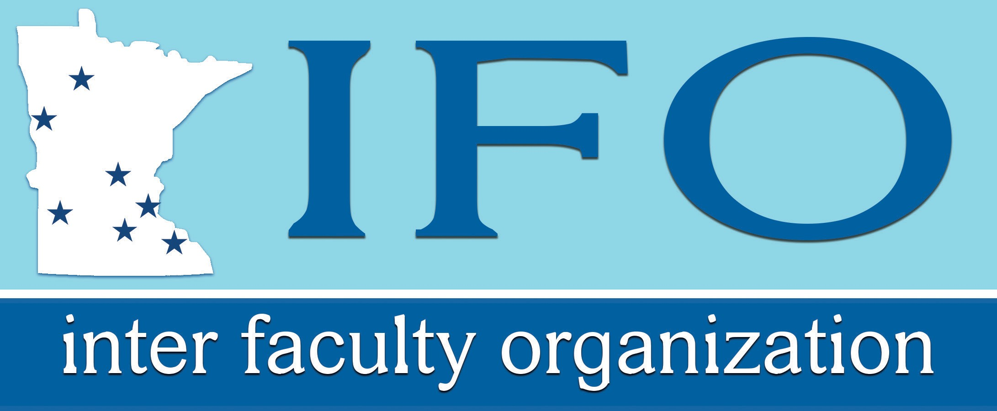

Retirement Issues for
New Faculty

2019 Workshop

Richard Kaspari

IFO Legal, Benefits, and Equity Representative

Disclaimer: This workshop is being conducted by the Inter Faculty Organization (IFO), the union of the faculty at the Minnesota State Universities, as a service to its members. The views expressed are those of the representative of the IFO, not the Minnesota State Colleges and Universities or any of its affiliated institutions. The IFO and its representatives do not sell or endorse any investment product or service and do not receive any fees, commissions, or financial reimbursement from any vendor of investment products or services. This workshop is designed to familiarize faculty members with options available to them under their retirement plans and collective bargaining contract. It is not to be construed as financial planning. The IFO encourages all members to seek financial advice from a licensed financial planner.

PURPOSE OF THIS RETIREMENT WORKSHOP

- To give you a general overview of your retirement programs, with emphasis on the decisions you must make in the near future.

- To help you make an informed decision between the Teachers Retirement Association ( TRA ) and the Individual Retirement Account Plan ( IRAP) as your basic pension coverage.

  - Almost all new faculty members will start out in the IRAP as their basic retirement plan. However, faculty members who have previous coverage in one of Minnesota’s defined benefits plans (TRA, MSRS, or PERA) will start out in TRA.

  - New faculty members who start out in IRAP have up to one year to switch to TRA as their basic pension plan and vice-versa. If you do nothing, you will stay in the plan to which you were initially assigned.

  - If you decide to switch from IRAP to TRA, that decision is irrevocable for life. If you select or default into IRAP and you later achieve tenure, you will get a second, one-year window during which they can switch to TRA.

  - The choice you make can mean the difference to you of thousands of dollars in the short term and hundreds of thousands of dollars over the course of your career and retirement. It can also affect the portability of your pension. The IFO wants you to make a careful and informed decision that best fits your plans.

- To introduce you to the Supplemental Retirement Plan (SRP), in which faculty members participate, beginning with their third year of full-time employment.

- To inform you of some large tax shelters and tax breaks available to you through the Voluntary Savings Plan (VSP), the State Deferred Compensation Plan, and the post-retirement Healthcare Savings Plan.

- To introduce the investment options and resources available in the IRAP and SRP.

  - Faculty in the IRAP, SRP, and VSP can choose between 28 investment funds. These include a range of assets types (stocks, bonds, money market, balanced funds, target date funds, etc.) The administrator of these Plans, currently TIAA, also provides investment education and counselling.

The Inter Faculty Organization is the union for the faculty at Minnesota’s seven state universities. The IFO is an informed, objective source of information. The IFO does not provide financial planning, endorse or sell any products or services, or receive fees or commissions relative to retirement. Our purpose in providing this workshop is to improve the economic welfare of the faculty.

MinnState RETIREMENT PLANS FOR FACULTY

Level 1. Social Security and Medicare (Mandatory)

Level 2. Basic Pension Plan (Mandatory)
All new faculty members who work more than 25% time must have a basic retirement plan.

Teachers Retirement Association
(TRA) OR
Individual Retirement Account Plan (IRAP)

Traditional teachers define benefit plan Personal investment account plan
Provides a post-retirement income based on Managed for MinnState by TIAA
years of service and “high five” salary 28 mutual funds and TIAA annuity options

One year to make a choice – the default is your initial plan if no other choice is made. Upon tenure, faculty members in IRAP will get a second opportunity to choose TRA.

Level 3. Supplemental Retirement Plan (SRP) (Mandatory)
The SRP covers all faculty members after two years of full-time employment.

- Managed by TIAA
- Same set funds as IRAP

The current contribution is 5% of salary over $6,000 per year, up to $2,250/year Matched 100% by the employer.

Level 4. Tax Sheltered Savings Plans (Voluntary)

Voluntary Savings Plan
also known as a 403(b) plan
- Managed for MinnState by TIAA
- Same statement as IRAP and SRP
- Both traditional and Roth options
- $19,000 Limit for < age 50
- $25,000 Limit for > age 50
AND/ OR
Deferred Compensation Plan
also known as a 457 plan
- Managed by the Minnesota State Retirement System (MSRS)
- Both traditional and Roth options
- $19,000 limit for < age 50
- $25,000 limit for > age 50

Faculty members can contribute to both, for combined limits of $38,000 for < age 50 and $50,000 for > age 50, plus additional “catch-up” contributions.

Level 5. Post-Retirement Healthcare Savings Plan (Mandatory)

- Severance Pay
- Health Reimbursement Arrangement

TRA vs. IRAP

Feature | TRA | IRAP
How the plan works | TRA is a defined benefit plan.  Assets are held collectively and invested by the State Board of Investment. Your benefit is based on a formula that is based on the average of your highest consecutive five years of salary. You get an annual retirement benefit at normal retirement age (age 66) that is equal to 1.9% of your high-5 average salary for each year of service. | IRAP is a defined contribution plan.  You have your own individual account into which both your contributions and your employer contributions are deposited. You choose where to invest your funds from an array of options. Your retirement benefits are based on how much you accumulate in your account from contributions and earnings.
Contributions | 7.75% for the employer, increasing to 8.75% by FY24  7.5% for employees, increasing to 7.75% in FY24 | 6% employer  7.5% employee, increasing to 7.75% in FY24
Vesting | After 3 years. If you do not vest, you can withdraw your own contributions, (not the employer’s contributions) with interest at the rate of 4%. | Both employer and employee contributions plus interest are immediately vested and belong to the employee.
Portability | Not very portable unless you go to work for another public employer within Minnesota. If you change jobs and move to another state or to the private sector, you can leave your | Very portable. If you change jobs mid-career you can either withdraw all the proceeds of your account (employer and employee) and roll it into a IRA rollover, transfer it to the

Feature | TRA | IRAP
Portability (continued) | contributions with TRA and begin drawing a reduced benefit at age 55, or an unreduced benefit at age 66, but your high-5 salary will be the salary you earned before you moved, so it will be eroded by inflation. If you withdraw before retirement you will get your own money back at 4% interest - you will forfeit the employer’s share and the interest thereon. | pension plan of a new employer (if they allow it). Because of IRAP’s excellent investment choices and very low fees, you may wish to simply leave your money in the plan until you retire and it will grow at the rate of investment return.
Risk | The primary risk is that you change jobs mid-career, which can have a serious adverse effect on your retirement benefits.  A second kind of risk is that your salary could grow at a slow rate. If this happens, “high-5” salaries increase slowly and therefore benefits grow slowly.  Finally, there is a political risk. Defined benefit plans are under attack by some legislators. Market losses by the plan can mean higher contributions or lower future benefit accumulation. | You bear the risk of investment.  If you invest wisely, and the financial markets cooperate, you can do very well.  If not…

Feature | TRA | IRAP
Benefit Options at Retirement | Your benefit is a guaranteed lifetime annuity (monthly income). You can choose from six (6) annuity options offered by TRA, including a single life annuity or different joint and survivor annuities. | You have very flexible benefit options, including annuities, lump sum withdrawals, interest only withdrawals, periodic payments, or combinations of the above.
Post Retirement Cost of Living Adjustments (COLA’s) | 1.0% per year increase in monthly benefit, increasing, starting FY24, to 1.5% per year in FY29. (Subject to future legislation.) | IRAP members can leave their money invested and it will grow (or shrink) at the rate of investment return until it is withdrawn. They can also purchase annuities with COLA’s.
Early Retirement Penalties | TRA’s “normal” retirement age is 66. If you retire earlier than the normal retirement age, and begin drawing your retirement benefit, that benefit is reduced for each year you retire prior to the normal retirement age. Those who reach thirty years of service and age 62 see smaller reductions. | The earlier you retire, the less money you will have accumulated in your retirement account, and that money will have to last through more years in retirement. Leaving MinnState before the year you turn 55 means a 10% withdrawal penalty until age 59½.
Generalizations | TRA is attractive for employees who think they will work in TRA covered employment throughout their career and retire close to TRA’s normal retirement age. It is an attractive alternative to people who are risk adverse when it comes to investments. | IRAP is attractive to people who think they are likely to change employers prior to retirement. Its greatest attraction is its portability. IRAP is also attractive to people who are not risk adverse when it comes to investments.

COMMON SENSE ABOUT INVESTING

Invest for the long term. Put a sizeable portion of your investment in equities (stocks), which have a high long-term yield compared to fixed interest investments and bonds. Ignore the short-term volatility--you should be concerned about what has the highest average yield in the long term. You will almost certainly have times when the market goes down, but if you are young, you can ride out the downswings.

- Diversify. Each of the investment funds available to you is diversified among many companies. However, you may want to diversify among asset types, such as real estate, bonds, and international investments, to reduce overall volatility of returns on your portfolio. How you diversify depends on your risk tolerance and years from retirement.

- Don’t chase the markets. Pick an asset allocation strategy and stick with it. By the time information relevant to making investment decisions reaches the average investor, the markets have already adjusted to the change. People’s instincts tend to be to want to buy when the market is going up and to sell when it is going down, just the opposite of “buy low--sell high”. Stay away from the “brokerage window” to outside stocks, bonds, and funds, unless you are a seasoned investor.

- Consider broad based index funds. Index funds tend to beat actively invested money of the same type about most of the time. Because they aren’t paying as much for high priced fund managers, index funds have much lower fees.

- Rebalance your asset allocations periodically. Because some asset types will increase faster or slower than others, your allocation percentages will get out of whack with your strategy. When you rebalance your asset allocations, you will be selling shares that are up in value to buy shares that are down in value--that’s a good strategy. Stick to your long-term allocation strategy.

- If you are uncomfortable investing, pick a “target date” fund.
Vanguard target date index funds do not require management, are diversified, and are automatically rebalanced to keep you on a “glide path” to your target date for retirement. They have very low fees.

VOLUNTARY TAX SHELTERING

There are two employer sponsored voluntary tax sheltering programs available to faculty through payroll deduction:
  - The Voluntary Savings Plan. This plan is often referred to as the VSP plan, the TSA plan (Tax Sheltered Annuity), or the 403(b) plan (because it is authorized under Section 403(b) of the Internal Revenue Code). This tax sheltering program is available under state and federal law for employees of non- profit educational and cultural institutions.
  - The State Deferred Compensation Plan. This plan is often called the Deferred Comp Plan or the 457 plan (because it is authorized under Section 457 of the Internal Revenue Code). This tax sheltering program is available to all public employees.
- Because faculty members are both educational employees and public employees, they qualify for both programs.
- The maximum percentage of salary that can be contributed to either of these plans is 100%. The maximum dollar amount that can be tax sheltered under each program is normally $19,000 per year - $25,000 if you are over age 50. The dollar amount that can be tax sheltered by participating in both programs is $38,000 per year
- $50,000 if you are over age 50.
- In addition to the normal contribution limits, there are special “catch-up” provisions for people that did not maximize their contributions in the past. Contact TIAA for details.
- The investment options in the VSP program are the same as under the IRAP plan and can be reviewed and evaluated at www.tiaa.org/public/tcm/minnesotastate/view-all-investment. The investment options under the Deferred Compensation program(s) are broadly similar in type. They can be reviewed and evaluated at www.msrs.state.mn.us/core-investment-options.
- The Voluntary Savings Plan and the Deferred Compensation Plan have slightly different withdrawal rules. The Voluntary Savings Plan has a 10% federal withdrawal penalty for withdrawals prior to age 59 ½, unless one retires at age 55 or older. The Deferred Compensation plan does not have this penalty. The Voluntary Savings Plan allows loans and “hardship” withdrawals, but the Deferred Compensation Plan does not.
- Both the TSA program and the Deferred Compensation program offer a traditional plan (where contributions are pre-tax and taxes are paid at the time of withdrawal), and a Roth plan (where contributions are made after-tax, but there are no taxes paid on either the principal or interest at the time of withdrawal).

16
Conventional or Roth?

Why would anyone choose to pay taxes now rather than later? The answer for some people is to have more tax-free income when they retire. The decision, however, is not the same for everyone and what is right for you depends on your individual situation.

Answer the questions below and follow the path indicated to make a preliminary determination as to which type of contribution -traditional pre-tax or Roth after-tax - might be best for you.

Do you have more than 10 years of work before you retire?

YES N O
I I
Are you currently Do you expect to be in
in a low tax bracket? the same or a higher tax (10% or 15%) bracket in retirement?

YES N O YES N O
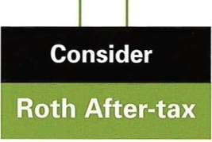
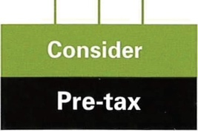
I
I
Do you expect to be in the same or a higher tax bracket at retirement?
YES
I
Can you afford to reduce your spendab le pay now to avoid taxes later?
YES
N
N O
N O
Can you afford to reduce your spendable pay now to avoid taxes later?

N O YES
I
Can you wait at least five years before you need your retirement money?

© copyright 2011 by NPI. All rights reserved.

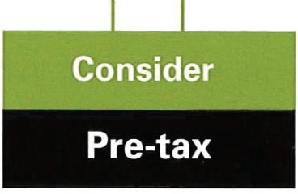
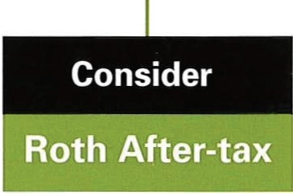
NO YES

The chart assumes you are contributing the same amount to the plan, whether you choose a traditional pre-tax contribution or a Roth after-tax contribution. With that approach, your spendable pay would be reduced during your working years by the amount of tax paid on the Roth after- tax contributions.

This chart is only intended to be a tool that can indicate which type of contribution might be right for you and is not intended to be tax, legal, or accounting advice. Your specific circumstances are not taken into account and may call for a different approach than the one indicated in the chart. Before deciding on a type of contribution, talk with a professional who can take into account any special factors that apply to you.

HEALTH CARE REIMBURSEMENT
The Postretirement Health Care Savings Plan (HCSP)
Faculty members are covered by a postretirement Health Care Savings Plan, administered by the MSRS. Money contributed to the HCSP is tax-free (not just tax deferred) so long as it is used for health-related expenses (deductibles, co-pays, health insurance premiums, vision and dental expenses, etc.). The money in your account is invested, with the same investment options as the MSRS 457 plan.

Three types of contributions go into the postretirement Health Care Savings Plan:
- Severance pay (which is based on unused sick leave). Generally, long term faculty members currently receive around $30,000 in severance pay.
- A $800 per year employer contribution—but only if the employee had accumulated
$700 or more balance in their HRA plan at the end of the prior year.
- A $250 payment on retirement.

Health Reimbursement Arrangements (HRAs)

All insurance eligible faculty (1/2 time or more) will receive a $800 employer contribution to their HRA account on January 1st of each year, to cover medical expenses not covered by insurance. Employees submit claims and are reimbursed from their accounts.

Unused balances in the HRA account carry forward and may be used in the subsequent year.

If at the beginning of a year an employee has less than $700 in their HRA account, the employee will have $800 added to their HRA account by the employer. If the employee has more than $700 in their HRA account the $800 will be added to their postretirement Health Care Savings Plan.

By controlling healthcare expenses during years of employment, employees can accumulate tax-free savings for their health care expenses following separation from employment.

Flexible Spending Accounts (FSAs)
Employees can voluntarily set aside up to $2500 of their own money through payroll deduction to pay for their uncovered medical expenses on a non-taxed basis through what are called Flexible Spending Accounts or FSAs. This is a great tax break, but FSAs have one major weakness—the balances in the FSA accounts at the end of a calendar year do not carry forward to the next year—they are forfeited to the employer.

Both the HRA and FSA programs are managed by 121 Benefits, and are coordinated so that if a member has an FSA, claims will be paid first from the FSA account (because it doesn’t carry forward to the next year) and then from the HRA account (because it does carry forward). You can open an FSA account upon the start of employment or during open enrollment in November of each year. Informational materials will be sent out prior to open enrollment.

IMPORTANT PHONE NUMBERS AND WEBSITES

Richard Kaspari, Benefits & Equity Representative
kaspari@ifo.org
651.227.8442 or 1(800) 325-9644 ext. 26

----

TEACHERS RETIREMENT ASSOCIATION
651-296-2409 or 800-657-3669
www.minnesotatra.org
-----
TIAA
1-800-682-8969
www.tiaa.org/public/tcm/minnesotastate

----
Minnesota State Deferred Compensation Plan

1-800-657-5757
651-296-2761
www.mndcplan.com
-----
121 Benefits (HRA & FSA Administrators)
800-300-1672
612-253-6633
www.121benefits.com

CAMPUS CONTACTS

Campus | Name | Phone | Email
Bemidji | Carol Hess | 218.755.2445 | chess@bemidjistate.edu
Mankato | Arielle Schmitz (A-L) | 507-389-1190 | arielle.schmitz.2@mnsu.edu
 | Sarith Phan (M-Z) | 507-389-1042 | sarith.phan@mnsu.edu
Metro | Kellie Cecil-Medina | 651-793-1298 | kellie.cecilmedina@metrostate.edu
Moorhead | Kayla VanderLinden | 218-477-2226 | kayla.vanderlinden@mnstate.edu
St. Cloud | Steve South | 320-308-3320 | ssouth@stcloudstate.edu
Southwest | Joan Tutt | 507-537-6209 | joan.tutt@smsu.edu
Winona | Jessica Wenzel | 507-457-5639 | jwenzel@winona.edu

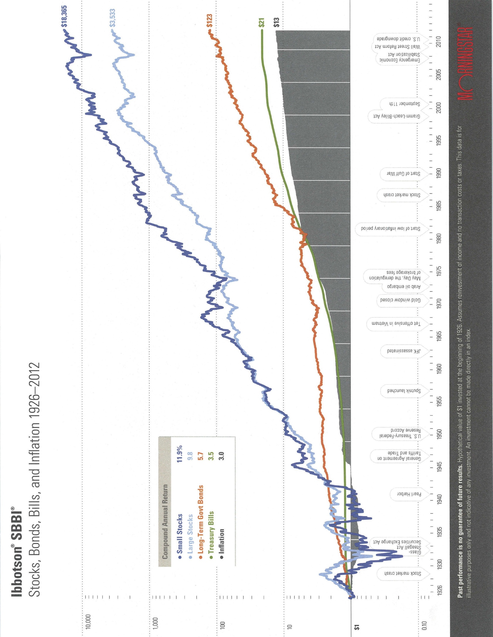

Page 24
Page 25

